

Kabir Singh Thukral
BCIS309 – Work Integrated Learning PROJECT, Networking
Semester 2, 2026
Kubernetes Observability Lab for Ara Institute of Canterbury
Halfway Report
Version 0.3

Table of Figures ii
Table of Tables ii
Proposal Marking Guide iv
Halfway Executive Summary 6
Halfway Project Scope 7
Reflection 8
Halfway Stakeholder Management 9
Reflection 9
Halfway Student Skills 10
Halfway Project Plan – High Level 11
Reflection 13
Halfway Risk Management 15
Reflection 17
Halfway Quality Assurance 18
Reflection 19
Halfway Methodology 20
Methodology Essay – Part 1 20
Introduction 20
Agile 20
Scrum 20
Testing and verification 21
How the methods have worked so far 21
Updates to the Methodology 21
Reflection 22
Halfway Professionalism Sustainability, Inclusive Practice and Te Tiriti o Waitangi 23
Sustainability 23
Inclusive practice 23
Relevant legislation 23
Te Tiriti o Waitangi and Te Ao Māori principles 24
Reflection 24
Halfway Self-Assessments 25
Industry 25
Academic 25
Halfway Reflections 26
Reflection 26
References 27
Appendices 28
Appendix A – Evidence of Industry Work - Halfway Report Phase 28
Appendix B – Evidence of Meetings – Halfway Report Phase 29
Appendix C – Evidence of Risk Management – Halfway Report Phase 30
Appendix D – Evidence of Quality Management – Halfway Report Phase 31
Appendix E – Evidence of Methodology in Action – Halfway Report Phase 32
Appendix F – Evidence of Project Planning in Action – Halfway Report Phase 32
Appendix G - Prompt Log (if GenAI used) 33

Table of Figures
Figure 1 Industry Burndown Chart at Halfway
Figure 2 Academic Burndown Chart at Halfway
Figure 3 Three-Node Lab Cluster with All Nodes Ready
Figure 4 Demo App and Monitoring Stack Pods Running on the Cluster
Figure 5 Grafana Dashboards Stored as ConfigMaps, Including dsys601-workload-health
Figure 6 Progress Meeting Form, 22/09/2026
Figure 7 Raising the inotify Limit Fixed the Cluster Start Failure (New Risk 9)
Figure 8 Pod Stuck Pending When the Node Holding Its Volume Was Unavailable
Figure 9 Redis Lost Its Test Key After One Container Restart (New Risk 10)

Table of Tables
Table 1 Proposal Improvement Actions
Table 2 Industry Requirements Status at Halfway
Table 3 Industry Deliverables Status at Halfway
Table 4 Project Stakeholders at Halfway
Table 5 Reports and Meetings at Halfway
Table 6 Skills Used and Learned at Halfway
Table 7 Updated Industry Project Plan at Halfway
Table 8 Updated Academic Plan at Halfway
Table 9 Updated Risk Table at Halfway
Table 10 Industry Quality Assurance Table at Halfway
Table 11 Academic Quality Assurance Table at Halfway
Table 12 Test Results Summary at Halfway
Table 13 Professional Standards Alignment at Halfway
Table 14 Te Ao Māori Principles Alignment at Halfway
Table 15 Industry Evidence Reports
Table 16 Sprint Review Summary
Table 17 Prompt Log
Industry Tasks Table
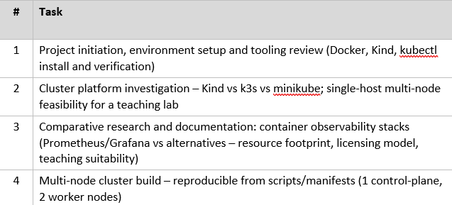
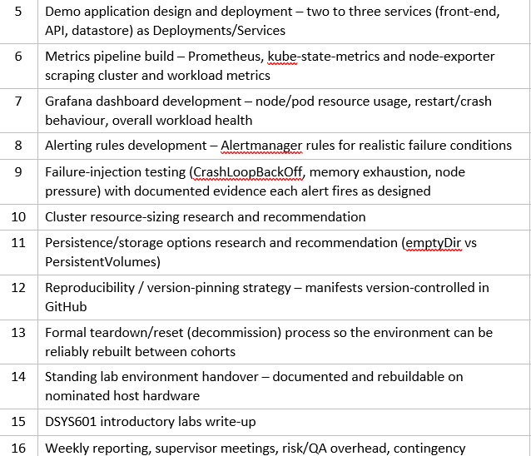

Document Control
Date | Author | Version | Status of Document/Updates Made
08/10/2026 | Kabir Singh Thukral | v0.1 | Document creation
16-10-2026 | Kabir Singh Thukral | v0.2 | Submitted for feedback
21/10/2026 | Kabir Singh Thukral | V0.3 | Submitted for feedback

Glossary
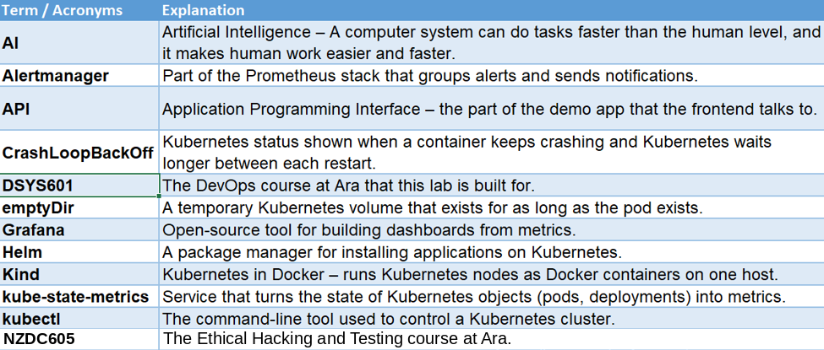

AI Usage Declaration
This report has been created by my own project finding. I have also listed below the tools that I have used for the success of this project.
- Microsoft Word and Microsoft Excel (Microsoft 365) – writing, formatting, my hours log and burndown charts.
- Grammarly – spelling and grammar suggestions.
- Claude (Anthropic), model Opus 5.5 – When I was doing my industry task then Claude was being used in different ways and helped me for guidance on commands, I also sent him the screenshots for the troubleshooting my errors which also helped me in making the evidence reports.

Proposal Marking Guide
My proposal was approved on 28 September 2026. Feedback was given by Dr David Weir in a one-to-one meeting, so I do not have a written marking guide to insert here.
In the table below I have mentioned all the things that David raised for updating my proposal.
After the meeting I also reviewed my proposal myself. The improvement actions are in the table below.
Table
Proposal Improvement Action
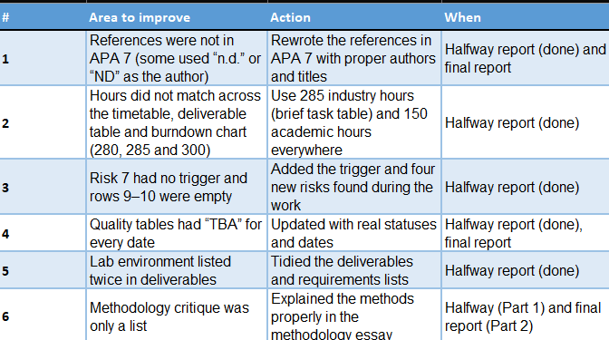

Halfway Executive Summary
This project is being done for Ara Institute of Canterbury for the Networking Team (Computing Department). The main aim for this project was to create a reusable, multi node Kubernetes observability lab so that the DSYS601 student (DevOps) can study and learn how to monitor and troubleshoot applications running on Kubernetes. My academic supervisor is Bernard Otinpong, and my industry supervisor is Abdul Rehman.
This project included basically 3 main goals to deliver which were providing the networking team with a lab which they can reuse with every new class, giving students a hands-on practice with Prometheus, Grafana, and alerting. The important and the main industry deliverables are the lab clusters, a small demo application, dashboard and tested alerts, research report on the platform, sizing and storage, a teardown and a reset procedure and introductory lab for DSYS601.
Agile approaches with scrum-style sprints have been used to plan the work. All the risks have been registered in my risk table which reviewed regularly, and every task has screenshots as evidence once they are completed. A task is only counted when it works, has evidence, and is accepted by the supervisors.
My proposal was signed off on 28 of September 2026, my most of the industry task from 1 to 14 was done mainly by 4 of October 2026 but still some of the tasks require some more corrections to be done as told by my industry supervisor. I am ahead according to my proposal plan which is good for the industry project. The work that has been done so far mainly includes 3 node kind cluster, a frontend, API and Redis demo app, Prometheus, Grafana and Alert manager, failure-injection testing, sizing and storage research, version control by GitHub, a teardown and a rest procedure which is required for the lab and a handover which is already tested by rebuilding the lab on a fresh college virtual machine. When the evidence of the work that I did was sent to Abdul in early October then he told me some correction which has to be done on task 9, 10 and 11 which was done and sent back to him also after that I started with the task 15 which was the DSYS601 lab write-up.
If I now talk about my academic side, then till now my CV, cover letter, WIL agreement and proposal have been signed off and submitted. The halfway report and the first part of the methodology essay are being done now. After this I will finish my final writing for the lab and complete the methodology essay, final report, short paper, poster and panel presentation by the mid of November 2026.

Halfway Project Scope
These are the updates at the halfway report:
- Platform: according to my task 2 research kind was recommended and then the lab was built according to that. The cluster runs on one host with one control plane node and two worker nodes on Kubernetes v1.37.0
- Demo application: my demo app has three services which are front end, an Api and Redis datastore
- Storage: according to my task 11 research I found out that empty Dir is better than Persistent Volumes for the lab
- Introductory labs (Task 15): I am writing several shorter labs which include all the work from task 1 to task 14 step by step. It covers Kubectl basics, deploying the demo app, installing the monitoring stack, building a dashboard, and firing the alert.
- Tidy-up: My proposal listed the lab environment and mixed headings into the requirement list. They have been grouped properly in the tables below.
Table 1
Industry Requirements Status at Halfway
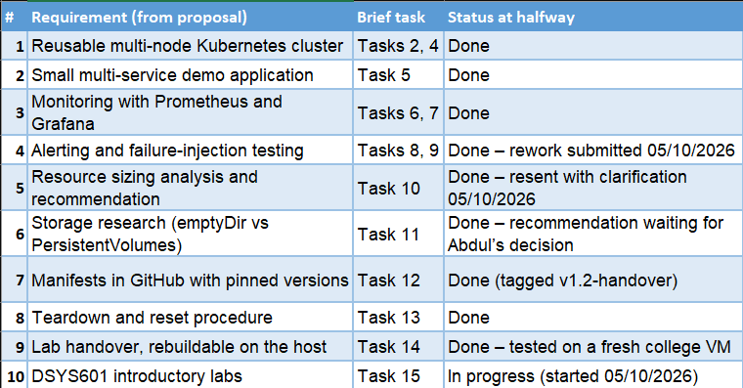
Table 2
Industry Deliverables Status at Halfway
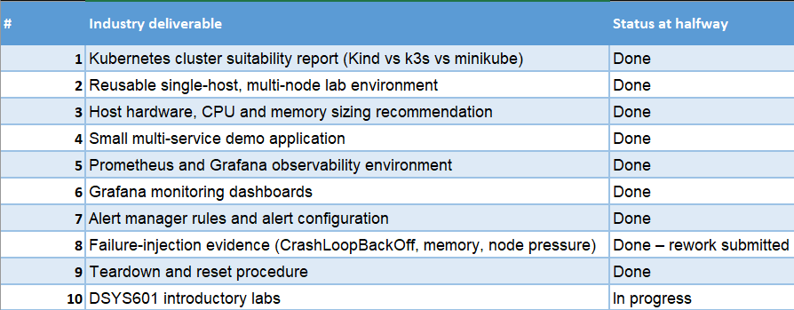

Reflection
What went well: There was a clear list of the tasks in the industry brief due which made it easy for me to make progress on it. I just keep matching every requirement according to each task and completing it and side by side also keeping a track of how many hours spent on each task. Building in small steps meant I always had something working to show.
What did not go well: Whenever I used to complete a task, I used to make a short report of it with the screenshots of the work and sent it to Abdul. Sometimes the requirements were not fully met, for example when I sent him the evidence for task 9 then he told me that he wanted a live kubectl threshold test with Alert manager not only the simulated test that I did.
Improvements: For the rest of my tasks, I used to confirm the requirements which are required before doing the task and make sure that it is being done fully, so the evidence that I collect matches what he expects.

Halfway Stakeholder Management
The stakeholders are the same since the proposal. Dr. Bernard Otinpong is my academic supervisor; Abdul Rehman is my industry supervisor. Dr David Weir and Phillip Roxborogh are the course convenors.
Table 3
Project Stakeholders at Halfway
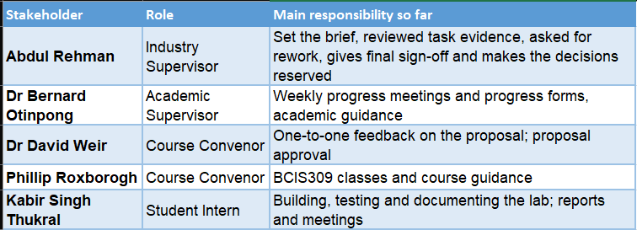
Table 4
Reports and Meetings at Halfway
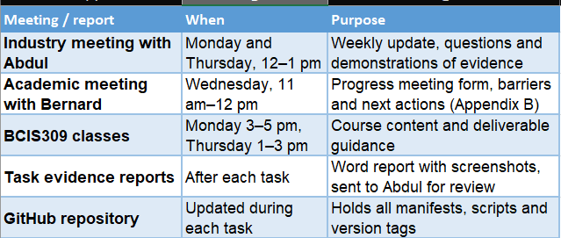

Reflection
What went well: The meetings were done on a regular basis with my academic supervisor and industry supervisor, and those meetings gave me a vision of what I am doing and will I do in future for this project. Both the supervisors used to give me quick feedback on the work I used to do and tell if something was wrong in it for example Abdul’s rework request was clear for task 9 which was failure-injection testing some more testing was required to be done, task 10 which was cluster resource-sizing research and recommendation, in that the report that I made for that task there was some mistake done which were highlighted by abdul which I fixed and task 11 which was Persistence/storage options research and recommendation (emptyDir vs PersistentVolumes) the recommendation was not strong enough to support so I also changed that. so I knew what exactly to fix.
What did not go well: There was a phase when I sent several tasks close together to Abdul for his review and his feedback, that gave Abdul a lot to review at once, and some gaps were found only at the end.
Improvements: Will try to send each piece of work or the evidence whenever I finish a task so that it is for both people to review and give feedback on it and then I can also fix that quickly.

Halfway Student Skills
The skills that I listed in in my proposal were used in making in this project also I also learned more skills for this making of this project.
Table 5
Skills Used and Learned at Halfway
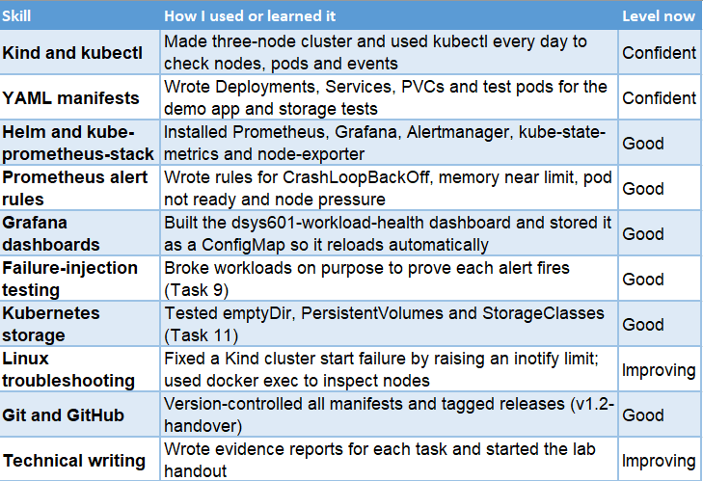

Skills that I learnt from my previous courses also helped me in making of this project for example, I used pod and Kubernetes DNS, which told me how the frontend works and how does API find Redis. From the course BCIS303, I used risk management to make sure I keep updating my risk up to date. From the course NZDC605 (Ethical Hacking and Testing). I used the skill of breaking the task into small pieces and which helped me complete it in a faster manner.
Skills still to build: I still need to learn how to write labs for students so that they can follow the instructions and then complete the lab, still need to learn skill for academic writing for the methodology essay and final report, and updating my personal presentation skills which will help me in presenting for the poster and the panel.
Reflection
What went well: I learnt how does Kubernetes works, which was a good thing for me. I learnt it by running the commands and fixing the real errors instead of just reading them.
What did not go well: I found out that writing the report after every completion of my task slows down my work in comparison when I do my actual technical work. I also underestimated some of the concepts, especially the Kubernetes storage and scheduling.
Improvements: I will try to divide my working time into two parts, one for the actual technical work and one for writing reports and gathering evidence which might make work easier for the upcoming tasks.

Halfway Project Plan – High Level
There were 6 academic phases that were planned for my project which were initiation, definition, design, development, implementation, and the follow-up. The initiation and definition phase is already done, design and development has also been completed and what is left now is the implementation phase and then after that the follow-up phase will come up which includes several things like final report, poster and panel.
The industry part had my biggest change in my project. Once the proposal was signed off and done, I started doing my work for the industry side, which went well. The planned sprints for my industry work were mid of October and November, but I was able to complete in by starting of October. I am using extra time for Abdul’s rework, the lab write-up, which is task 15 and my academic deliverables as well.
Table 6
Updated Industry Project Plan at Halfway
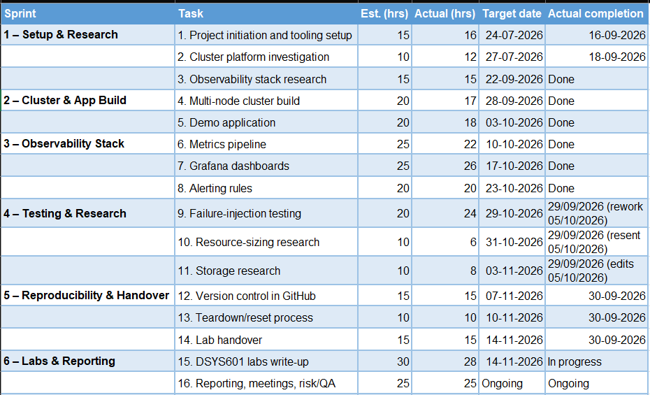
Table 7
Updated Academic Plan at Halfway
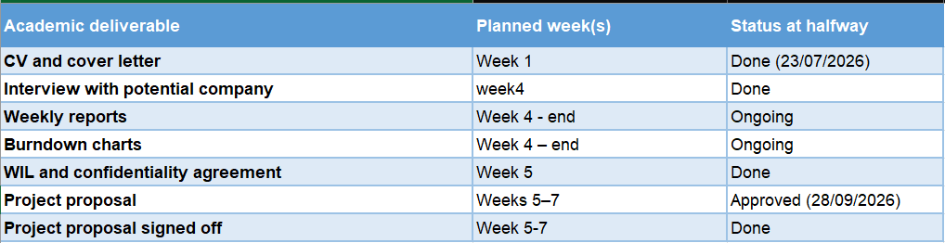
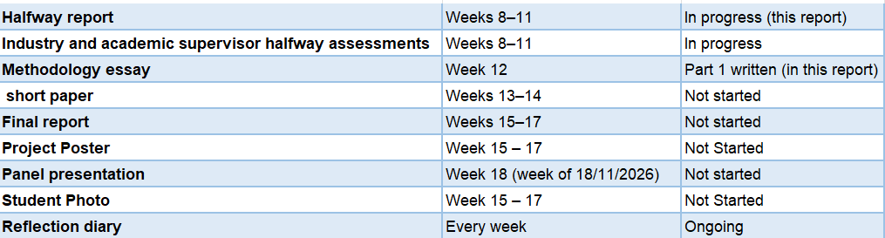
The burndown charts below are updated to the halfway point. The industry chart starts at 300 hours, and the academic chart starts at 150 hours.
Figure 1
Industry Burndown Chart at Halfway
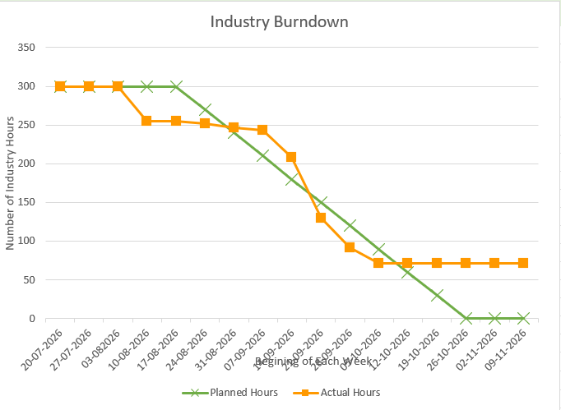
Figure 2
Academic Burndown Chart at Halfway
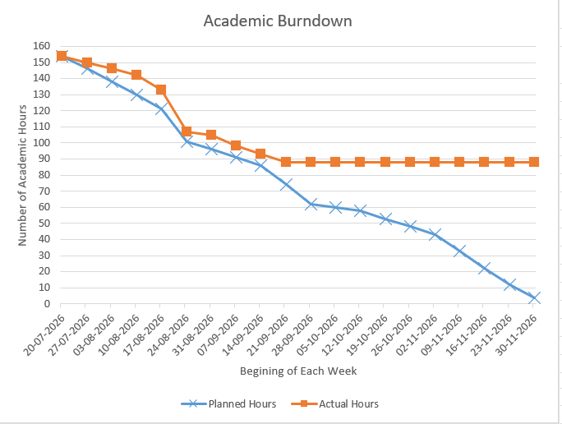
Evidence of the industry work done so far is in Appendix A

Reflection
What went well: Making sprints for each task helped me in managing the work easily and finishing the work little before the time helped me in giving some more time for the rework and for the academic deliverables as well.
What did not go well: my original target dates were too cautious, so the plan stopped matching reality quite quickly.
Improvements: I will update my hours log and both burndown charts every Friday, and change target dates as soon as I know a task will finish early or late.

Halfway Risk Management
The risks that I have used here are mostly the same as the risk table that I used in my proposal. Every risk is registered with a probability, impact and exposure of each risk before and after the mitigation, and I will review it each week and discuss it with my supervisor if I have any major risk.
I have updated the risk in the following table that were missing and also added four more risk that came up during my task for this project no risk has been removed but most of risk have been lowered down as the task are coming to end the updated risk table is below.

Table 8
Updated Risk Table at Halfway
# | Condition | Consequence | Probability(1%-99%) | Impact (1-10) | Exposure | Mitigation | Probability(1%-99%) | Impact (1-10) | Exposure | Contingency | Trigger | Halfway update
1 | Lack of technical skills | Hard to configure and troubleshoot the cluster and tools | 20% | 8 | 1.6 | Documentation, tutorials, testing, supervisor help | 10% | 6 | 0.6 | Review documentation and ask supervisor | Repeated technical errors | Lower – Tasks 1–14 built and tested
2 | Struggle to adapt to company workflow | Tasks take longer | 35% | 8 | 2.8 | Regular meetings, follow agreed workflow | 15% | 5 | 0.75 | Discuss with supervisor, adjust plan | Missed tasks or repeated corrections | Lower – settled into evidence-report workflow
3 | Lack of communication | Requirements misunderstood, rework | 30% | 7 | 2.1 | Weekly meetings; confirm acceptance criteria before each task | 25% | 6 | 1.5 | Extra meeting to clarify | Unclear requirements or rework requests | Happened once – rework on Tasks 9–11, submitted 05/10/2026
4 | Poor time management | Deliverables delayed | 30% | 6 | 1.8 | Follow timetable, weekly review | 15% | 4 | 0.6 | Reprioritise tasks | Missed deadlines | Lower – industry work ahead of plan
5 | Illness | Work interrupted | 15% | 5 | 0.75 | Documentation and Git commits | 10% | 5 | 0.5 | Inform supervisors, revise schedule | Unable to attend or work | No change
6 | Single-host cluster failure | Lab unavailable | 30% | 9 | 2.7 | Scripted builds in Git | 10% | 6 | 0.6 | Rebuild from Git | Nodes NotReady or host crash | A node restarted during Task 9; lab recovered. Full rebuild tested on fresh VM
7 | Host resource exhaustion | Pods or services fail | 40% | 8 | 3.2 | Resource requests and limits (Task 10) | 15% | 5 | 0.75 | Reduce load, restart pods, adjust limits | Added: node shows MemoryPressure or DiskPressure, or pods are evicted | Trigger added (was missing)
8 | False positive alerts | Unneeded investigation | 35% | 6 | 2.1 | Calibrate thresholds with failure injection | 10% | 4 | 0.4 | Adjust alert rules | Alert fires with no real failure | Lower – thresholds checked in Task 9
9 | New: host setting (inotify limit) too low or lost after reboot | Second cluster or rebuild fails to start | 40% | 6 | 2.4 | Make setting permanent in /etc/sysctl.d; add to handover notes | 10% | 4 | 0.4 | Re-apply with sudo sysctl -w | kind create cluster fails at node start | Found in Task 11 and fixed
10 | New: Redis has no volume | Demo data lost on a container restart | 50% | 4 | 2.0 | Add emptyDir (recommended in Task 11) | 20% | 3 | 0.6 | Restart the API to reload data | Redis restarts and data is missing | Waiting for Abdul’s decision
11 | New: late rework or sign-off delays | Final deliverables delayed | 30% | 7 | 2.1 | Send work for review early; confirm criteria | 15% | 6 | 0.9 | Extra meeting; reprioritise | No reply within a week or new change requests | Watching
12 | New: academic deliverables fall behind | Essay, final report, poster rushed | 40% | 8 | 3.2 | Weekly academic plan; start essay now | 20% | 6 | 1.2 | Talk to Bernard; reprioritise | Academic burndown behind plan two weeks in a row | Main focus for the second half

Reflection
What went well: the mitigations in my proposal worked. Keeping the cluster build scripted in Git meant that when a node restarted during testing, recovery was easy, and the fresh-VM rebuild proved the lab can be recreated from scratch.
What did not go well: I did not spot some risks until they happened, such as the host inotify limit and Redis having no volume. Risk 7 also had no trigger in my proposal.
Improvements: I will add a new risk to the register as soon as a test shows something unexpected, rather than waiting for the weekly review. I will also check that every risk has a clear trigger.

Halfway Quality Assurance
The quality approach is the same until now I get regular feedback from both my supervisors to make sure everything is correct. When a task is done, I usually take a screenshot of it to keep it as evidence for the supervisors and make sure my progress for my industry work is getting saved in my GitHub repository.
I made three updates to the approach during the first half:
- Every industry task now has its own evidence report with screenshots of the commands and results.
- Instead of assuming how something behaves, I test it. For example, in Task 11 I tested each storage type rather than relying on documentation alone.
- I tested the full rebuild on a fresh college VM (Task 14) to prove the lab can be rebuilt from the GitHub repository.
Table 9
Industry Quality Assurance Table at Halfway
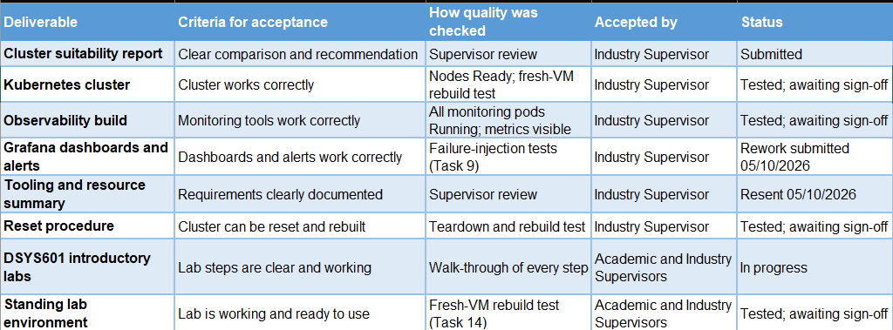
Table 10
Academic Quality Assurance Table at Halfway
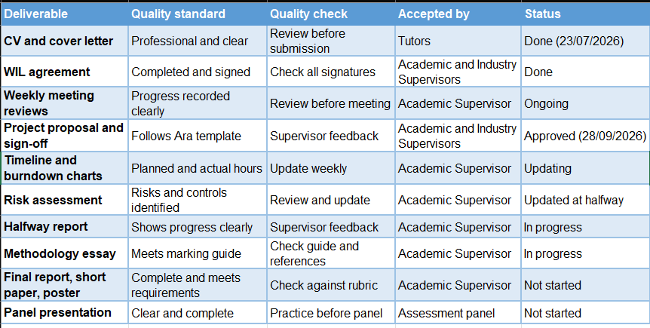
The tests from my proposal’s test plan have now been run. The results are summarised below, and the evidence is in Appendices A and D.
Table 11
Test Results Summary at Halfway
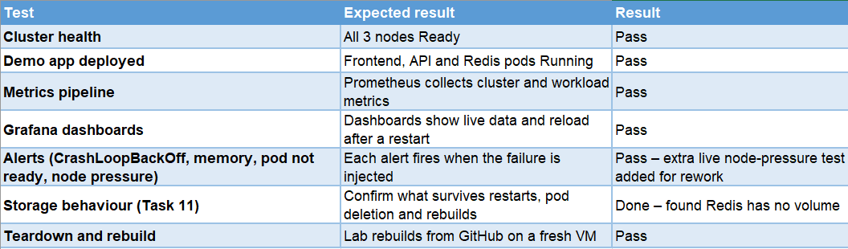

Reflection
What went well: Every task was tested and then the evidence was made in which i also included my screenshots that gave me strong evidence of completion of every task and that helped in making the evidence reports easier. Testing everything instead of assuming things also made things easier to find real problems.
What did not go well: my definition of done did not say exactly what evidence Abdul needed, which is why some tasks needed rework.
Improvements: I will add “evidence agreed with supervisor” to my definition of done and ask someone to try the lab handout before I submit it.

Halfway Methodology

Methodology Essay – Part 1

Introduction
For the industry project I am creating a reusable Kubernetes observability lab for the course DSYS601 course at Ara which is a part of networking part of our IT sector. It includes different small parts of technical steps, for example building a cluster, deploying a demo app, setting up monitoring, and then testing the alerts that actually works. All these tools and features were interconnected and before building and testing them I did not know how it would behave. This was the reason why I chose Agile as my overall approach, Scrum as the framework for organizing the work into sprints and then making sure that each part works with the help of testing and verification method. In this I am basically explaining what each method is, what was the reason for choosing it and how I will be using it for my first half of my project.

Agile
Agile is a way to work in which a project is built into smaller pieces and then taking regular feedback from supervisors instead of delivering everything at once. This agile way comes from agile manifesto, in which interactions are done with the individual over the processes and the tools, working software over the comprehensive documentation and responding if there is any change over the following plan (Beck et al., 2001). In this, the work is completed in short cycles by showing the progress and changing direction if there is any need after getting feedback (Gurnov, 2026).
There are various reasons which set the Agile as the best option for my project. Firstly, the technology that I was using for this project was new to me, so I expected to learn new things while building this project. Secondly, I used to take regular feedback from industry supervisor when I used to complete my task and agile is also of this kind which includes taking regular feedback. Thirdly the project itself is break down in several tasks and it fits well in building and checking one piece at a time because if i would have completed all the whole project and then taken feedback then it could have created more mess due to which completing the task into smaller pieces and taking feedback was good idea for making success of this project.

Scrum
Scrum is a framework for putting the Agile into practice. The work was spliced into smaller parts which were the sprints, and the aim was to produce a good amount of work at the end of each sprint. (Schwaber, 2026). This guide describes three roles, five events, and three artefacts (Schwaber & Sutherland, 2020).
Scrum is basically made for working in teams, so I had to adapt it for a one-person project. In this, I acted as both the developer and the scrum master. Abdul acts like a product owner because he wrote the project brief and he set the priorities and he is the one who is going to decide if the work is accepted or not. There were in total 16 tasks and it got divided into 6 different sprints which are setup and research, cluster and application build, observability stack, testing and sizing research, reproducibility and handover, and labs and reporting. The weekly meeting that I used to have with Abdul was like the sprint review where I get to know what progress I have made and if there is something to be corrected. My progress meetings with Bernard work like retrospectives, because the progress form asks what went well, what the barriers were, and what I will do next. I keep daily notes and an hour's log.

Testing and verification
The third method which is being used here is testing and verification. A testing methodology makes sure that the work that has been completed is done in a correct manner and is giving the expected results, and if there are any issues or problems in it then it can be fixed before the work is submitted (Khan, 2026). All, the testing has been done after the completion of each task instead of keeping it for the later time once the project is over. For example, when the cluster was once ready then it was made sure by testing that all three nodes are ready and after deploying the demo app I made sure that each pod was running.
The most important part for this project was failure injection, which means breaking things on purpose. In task 9 a container was made and it crashed repeatedly, used a container close to its memory limit and put a node under pressure, then checked that the matching alert fired in Prometheus and Alert manager. In Task 11, I used the same idea for storage. Instead of trusting what I had read, I tested what happens to data when a container restarts, when a pod is deleted, when a node is unavailable, and when the whole cluster is rebuilt. When these tests were done, I got to know that Redis database has no storage volume due to which it loses its data every time the container is restarted. I would have not got to know about that without actually doing it. Every test was recorded with screenshots, and they helped as an evidence for my reports.

How the methods have worked so far
These methods have worked perfectly fine until now. Building in sprints meant I always had a working part of the lab to show, and this helped me in completing the task quickly and easily I was able to complete task from task 1 to task14 by the starting of the October. The best example of Agile feedback came in starting of October when Abdul reviewed my work and gave feedback on it and because the task was completed in smaller bit that helped fixings the things that went wrong in-between of my tasks without affecting my rest of the lab.
There have also been some challenges. Scrum events can feel heavy for a one-person project, and I had to decide which parts were actually useful to me. Agile also says working software is more important than documentation, but in a teaching lab the documentation is part of the product, because students need clear instructions to follow. I have had to balance building and writing more carefully than a normal software project would. These points will be discussed further in Part 2 of the essay.

Updates to the Methodology
The three methods are the same as in my proposal. The main change is how I use them: I added a written definition of done, the weekly Abdul meetings now work as sprint reviews, and Sprints 2 to 5 were finished faster than planned, so Sprint 6 (labs and reporting) has started early.

Reflection
What went well: By using the testing method I was able to find real problems and sprints and regular testing worked well for my technical project.
What did not go well: I sometimes moved on to the next sprint before getting formal feedback on the last one, which led to rework later.
Improvements: I will only close a sprint once Abdul has reviewed its work, and I will hold a short retrospective with myself at the end of each sprint and write it in my reflection diary.

Halfway Professionalism Sustainability, Inclusive Practice and Te Tiriti o Waitangi
The approach was kept same as the proposal. I tried to do things professionally and use resources responsibly so that when the students do the lab it becomes easier for them while practicing on it. Table below show the findings of what I have done so far.
Table 12
Professional Standards Alignment at Halfway
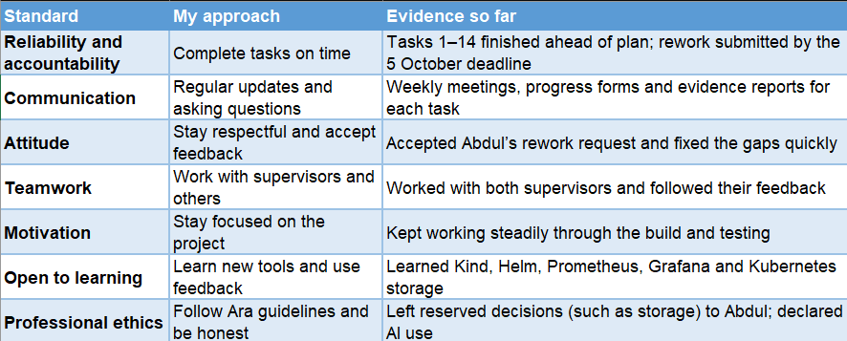

Sustainability
The lab runs on one host using Kind, which runs all three nodes as containers instead of three separate machines. This uses much less hardware and power. The resource sizing in Task 10 recommends requests and limits so the lab does not use more than it needs, and the teardown process means the lab can be removed completely when it is not in use. All the tools are open source, so there are no licence costs, and the lab can be reused by every new DSYS601 class instead of being rebuilt from nothing.

Inclusive practice
I am writing the lab handout in plain language, with every command shown and screenshots of what students should see. This helps students who are new to Linux or Kubernetes, or who speak English as a second language. The lab runs on a standard college VM, so students do not need their own powerful computer.

Relevant legislation
The lab does not use any personal information, and I keep project information confidential in line with the Privacy Act 2020 and Ara’s guidelines. Under the Copyright Act 1994, I reference any outside sources I use. The open-source tools are used under their licences: Kubernetes, Kind and Prometheus use the Apache 2.0 licence and Grafana uses the AGPLv3 licence.

Te Tiriti o Waitangi and Te Ao Māori principles
Table 13
Te Ao Māori Principles Alignment at Halfway
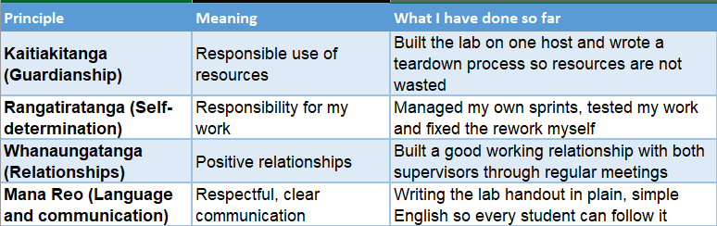

Reflection
What went well: I met my deadlines, responded well to feedback and respected the decisions that belong to my supervisor.
What did not go well: I have not yet tested the lab handout with real students, so I cannot be sure it is fully inclusive.
Improvements: I will ask a classmate or tutor to follow the handout and give feedback, and I will think more about how the labs can connect to the New Zealand context.

Halfway Self-Assessments

Industry
Insert a copy of my industry self-assessment using the halfway rubric.
Summary: I think my industry work is strong at the halfway point. All the build and research tasks (1 to 14) are finished and tested, with evidence for each one. My main area to improve is making sure my evidence matches what my supervisor expects the first time, so that less rework is needed.

Academic
Insert a copy of my academic self-assessment using the halfway rubric.
Summary: my academic work is on track but needs more focus in the second half. The proposal is approved and the halfway report is done, but the methodology essay, final report, poster and panel presentation are still ahead of me.

Halfway Reflections
There is no major changes for the approach to reflection, there is some minor updates like now I reflect in three different ways the progress meeting form with Bernard each week in which we discuss what went well, if there were any barriers and how did I resolved them and what is the plan for next meeting. From now I will also write a short note at the end of each meeting sprint what would I do differently.

Reflection
What went well: the weekly progress forms made me stop and think about my progress, and they helped me notice when I was ahead or behind.
What did not go well: while I was busy with the build, I did not always write my reflection diary straight away, so some entries were written days later and were less detailed.
Improvements: I will write a short diary entry at the end of each working day, even if it is only a few lines, and look back over it before each supervisor meeting.

References
Ara Institute of Canterbury. (n.d.). About us. https://www.ara.ac.nz/about-us/
Beck, K., Beedle, M., van Bennekum, A., Cockburn, A., Cunningham, W., Fowler, M., Grenning, J., Highsmith, J., Hunt, A., Jeffries, R., Kern, J., Marick, B., Martin, R. C., Mellor, S., Schwaber, K., Sutherland, J., & Thomas, D. (2001). Manifesto for Agile software development. https://agilemanifesto.org/
Gurnov, A. (2026, March 30). How Agile software development works. Wrike. https://www.wrike.com/project-management-guide/faq/how-agile-software-development-works/
Khan, M. K. (2026, June 17). What is software test methodology? BrowserStack. https://www.browserstack.com/guide/software-testing-methodologies
Moorfield, J. C. (n.d.). Te Aka Māori dictionary. https://maoridictionary.co.nz/
Privacy Act 2020. (NZ). https://www.legislation.govt.nz/act/public/2020/0031/latest/whole.html
Schwaber, K. (2026, January 15). What is Scrum? Scrum.org. https://www.scrum.org/resources/what-scrum-module
Schwaber, K., & Sutherland, J. (2020). The Scrum guide. https://scrumguides.org/scrum-guide.html

Appendices
The appendices below hold the evidence referred to in the main report. Each appendix holds one kind of evidence: industry work, meetings, risk management, quality management, methodology, project planning and the prompt log.

Appendix A – Evidence of Industry Work - Halfway Report Phase
A separate evidence report with screenshots was written for each industry task and sent to Abdul. All manifests and scripts are in the project GitHub repository: https://github.com/kat0870/dsys601-k8s-observability-lab (tag v1.2-handover). The table below lists the evidence, and the screenshots that follow are examples from the lab.
Table 14
Industry Evidence Reports
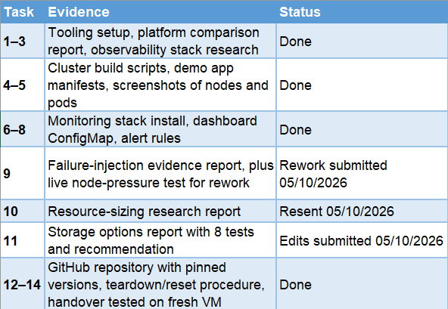
Figure 3
Three-Node Lab Cluster with All Nodes Ready
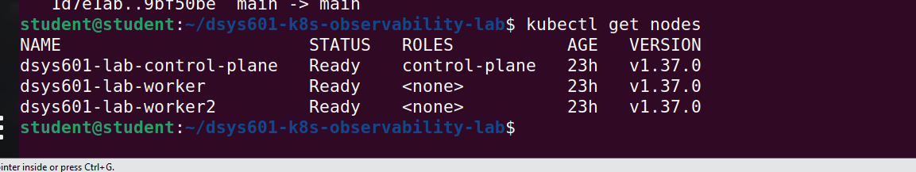
Figure 4
Demo App and Monitoring Stack Pods Running on the Cluster
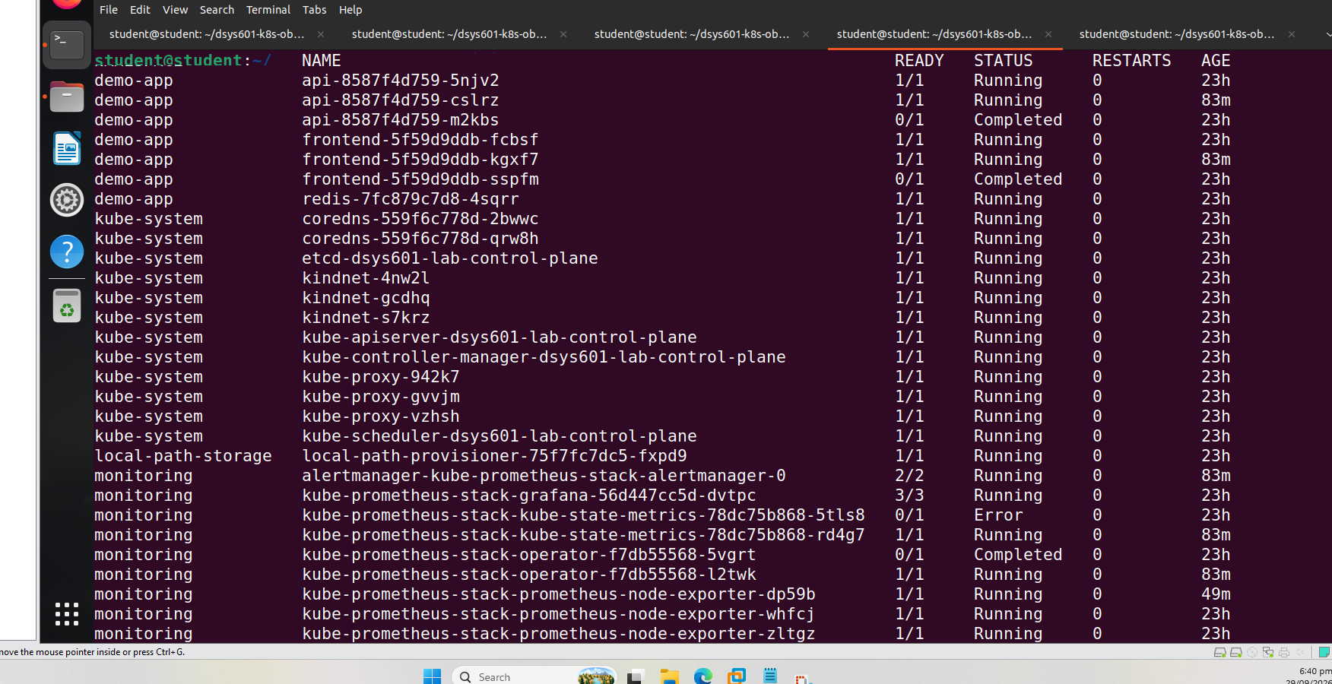
Figure 5
Grafana Dashboards Stored as ConfigMaps, Including dsys601-workload-health
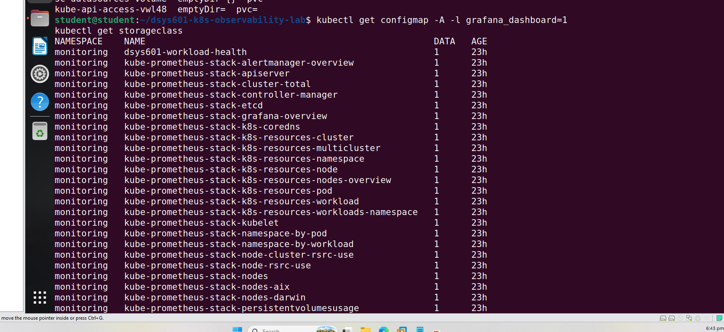

Appendix B – Evidence of Meetings – Halfway Report Phase
Below is an example of my weekly progress meeting form with my academic supervisor.
Figure 6
Progress Meeting Form, 07/10/2026
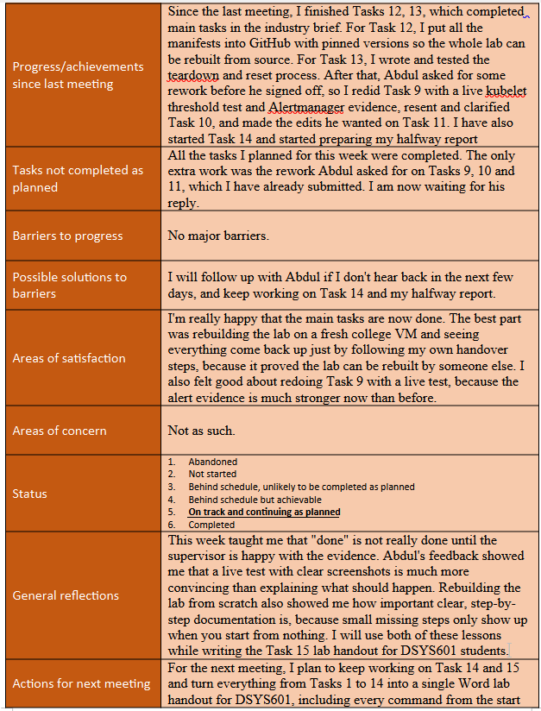

Appendix C – Evidence of Risk Management – Halfway Report Phase
New risk 9 was found during Task 11. A second Kind cluster would not start because the host’s inotify limit was too low. I raised the limit, and the cluster started straight away. This is now in the risk register and the handover notes
Figure 7
Raising the inotify Limit Fixed the Cluster Start Failure (New Risk 9)
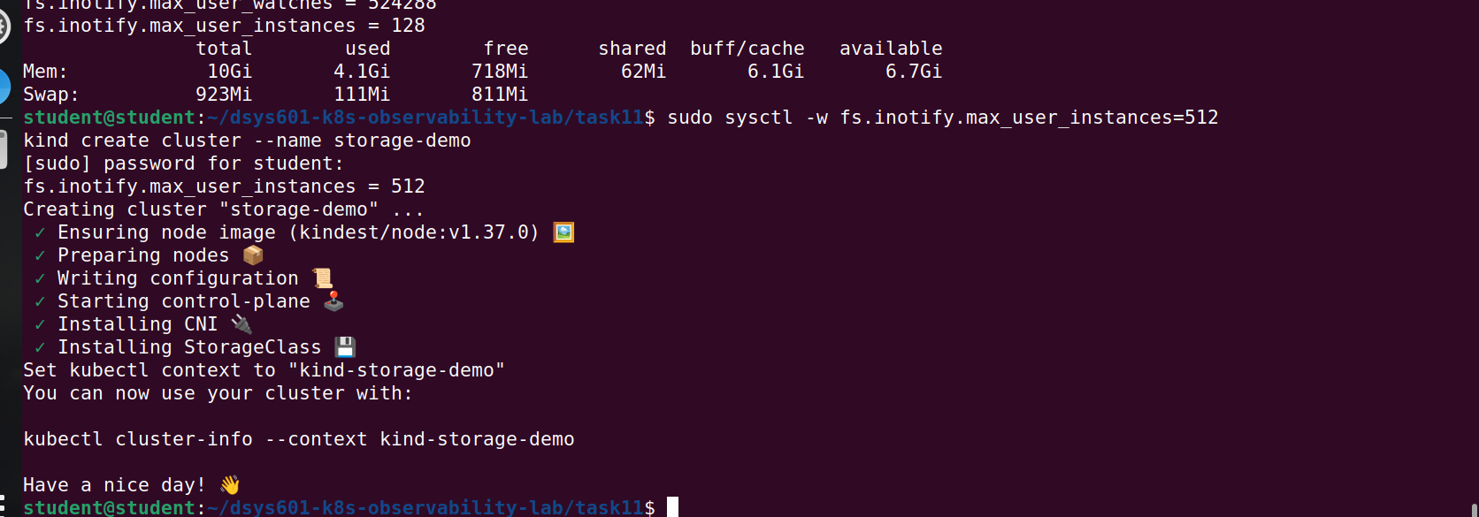

Appendix D – Evidence of Quality Management – Halfway Report Phase
These screenshots are from my Task 11 storage testing. They show the “test, don’t assume” approach
Figure 8
Pod Stuck Pending When the Node Holding Its Volume Was Unavailable
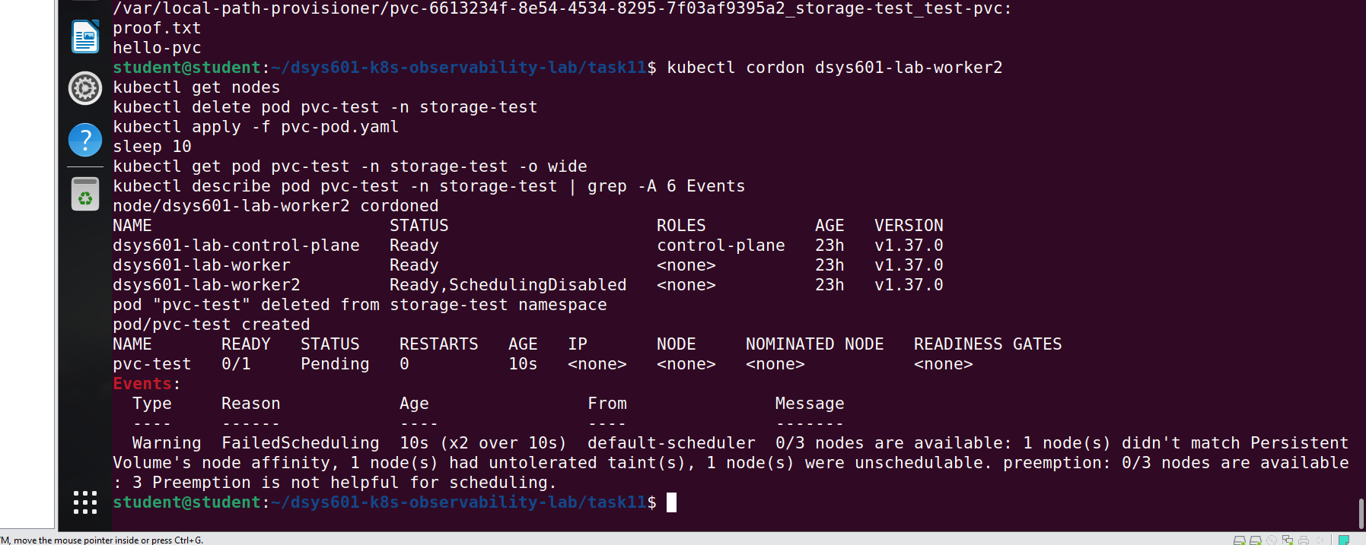
Figure 9
Redis Lost Its Test Key After One Container Restart (New Risk 10)
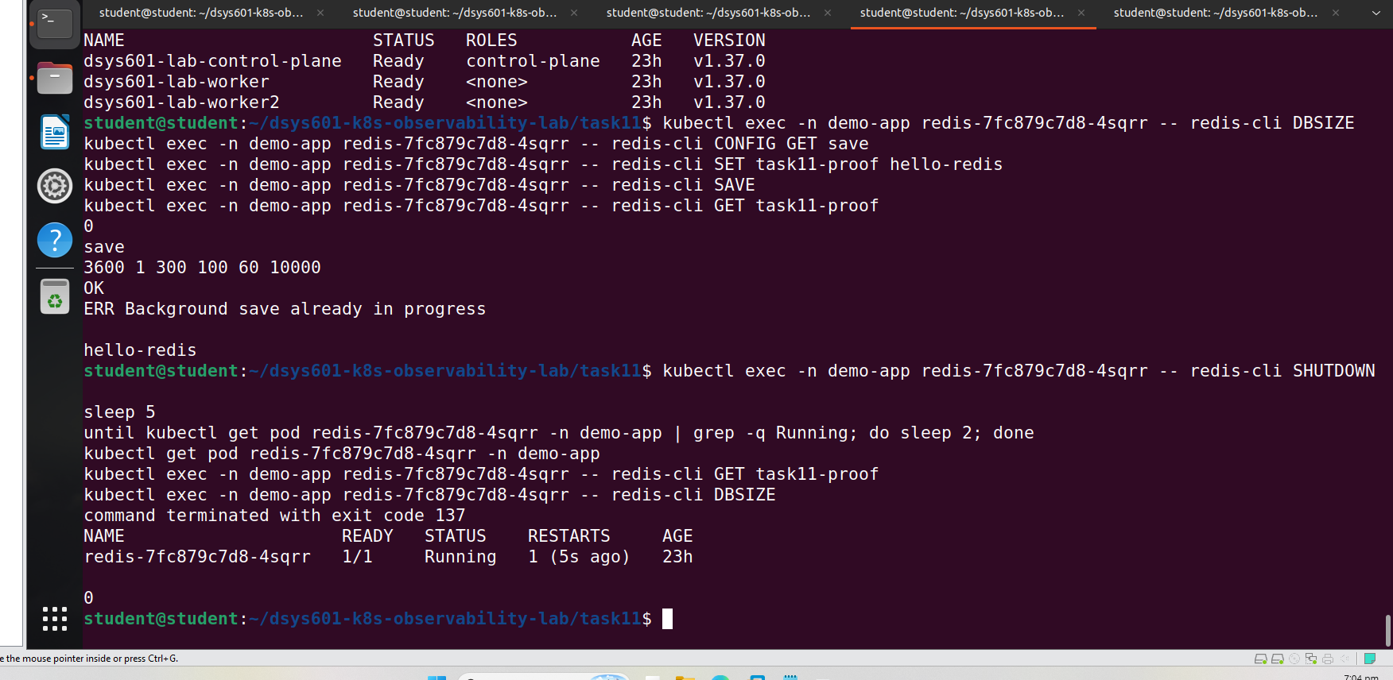

Appendix E – Evidence of Methodology in Action – Halfway Report Phase
The table below shows how the sprints worked in practice, including the review feedback from each one.
Table 15
Sprint Review Summary
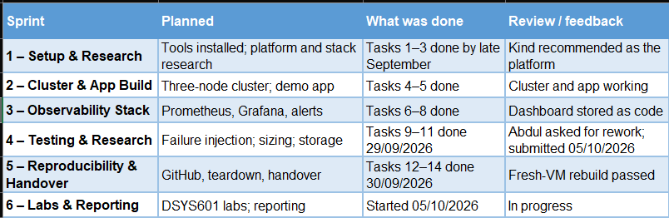

Appendix F – Evidence of Project Planning in Action – Halfway Report Phase
The updated industry and academic plans are in the Halfway Project Plan section. My weekly hours log is kept in Excel.
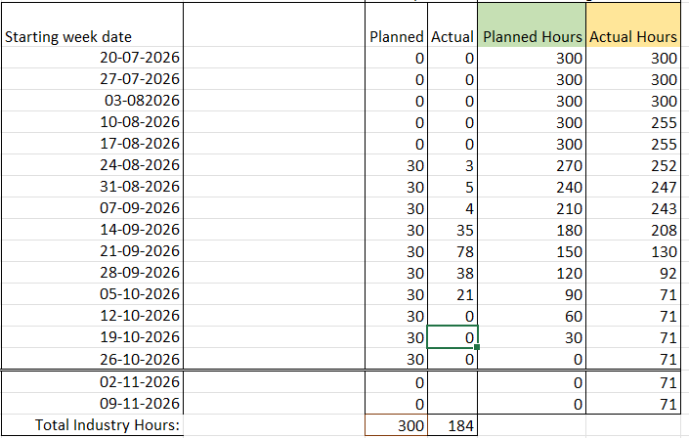

Appendix G - Prompt Log (if GenAI used)
This log shows where I used Claude (Anthropic) during the halfway phase, what it gave me and what I did with it.
Table 16
Prompt Log
